RAMDEOBABA UNIVERSITY, NAGPUR
DEPARTMENT OF COMPUTER SCIENCE AND ENGINEERING
B.Tech. CSE (Artificial Intelligence and Data Science)
SEMESTER V | SI LAB PROJECT REPORT

USED LAPTOP RESALE VALUE PREDICTION

Submitted by
Student Name | Roll No. | Section / Batch | Enrollment No.
Sanika Bhanuse | 21 | B2_B2 | ________________

Academic Year: 2026–27

1. PROJECT OBJECTIVE
The objective of this project is to build a machine-learning application that estimates a laptop's price from selected specifications and assigns the laptop to a price segment. The project demonstrates data collection, data cleaning, exploratory data analysis, statistical analysis, regression, classification, model evaluation, and a graphical user interface.
- Collect laptop listing data and prepare a structured CSV dataset.
- Explore the dataset using descriptive statistics and visualizations.
- Derive five input features: Rating, Reviews, RAM_GB, Storage_GB, and Screen_Size.
- Train and compare regression models for numeric price estimation.
- Train and compare classification models for Budget, Mid-Range, and Premium price categories.
- Expose predictions through an interactive interface and discuss the model's limitations.

2. INTRODUCTION
Laptop prices vary according to hardware specifications, condition, popularity, and market demand. Estimating a fair resale value can help a seller make an initial pricing decision before listing a device. This project uses a small dataset of laptop listings and supervised machine-learning methods to demonstrate price estimation and price-tier classification.
The notebook collects product listing information from the Web Scraper e-commerce laptop test site, cleans the records, derives numerical features from the description field, and uses the listed Price as the target variable. The interface presents an estimated dollar price and a predicted category. The available dataset is a small product-listing dataset rather than a verified transaction dataset of used-laptop resale sales; therefore, results should be treated as a demonstration, not a guaranteed market valuation.

2.1 Problem Statement
Given a laptop's rating, number of reviews, RAM, storage, and screen-size value, estimate its listed price and classify it as Budget, Mid-Range, or Premium.

2.2 Scope of the Project
The project covers a 117-record dataset, feature extraction, exploratory and statistical analysis, five regression algorithms, three classification algorithms, model comparison, and an interactive prediction interface. It does not verify device age, physical condition, battery health, warranty, exact processor/GPU, local currency, or actual resale transaction prices.

3. PROJECT METHODOLOGY

3.1 Dataset Loading and Exploration
The notebook uses Python requests and BeautifulSoup to scrape laptop listing information from the Web Scraper static e-commerce test site. The cleaned file is named cleaned_used_laptops.csv. It contains 117 rows and eight columns: Laptop_Name, Price, Description, Reviews, Rating, Screen_Size, RAM_GB, and Storage_GB.
The five model input features are Rating, Reviews, RAM_GB, Storage_GB, and Screen_Size. Price is the regression target. For classification, Price is converted into three approximately equal-sized rank-based categories: Budget, Mid-Range, and Premium.
Dataset property | Observed result
Number of records | 117
Mean listed price | $909.39
Price standard deviation | $401.31
Mean reviews | 6.90
Mean rating | 2.34
Missing values in cleaned columns | 0 reported
Duplicate records | Checked in notebook; no duplicate count recorded here

Exploratory analysis includes price and review histograms, rating counts, a price box plot, a correlation heatmap, and scatter plots comparing price with RAM and storage. The notebook also calculates variance and standard deviation, samples 30 records, demonstrates sampling-distribution/central-limit-theorem concepts, computes a 95% confidence interval, and performs t-test, z-test, ANOVA, and chi-square analysis.

3.2 Data Preprocessing
- Convert the Price column from currency-formatted text to numeric values.
- Extract screen-size, RAM, and storage values from Description and save them as numerical columns.
- Convert model features and target values to numeric form and handle invalid or missing values in the modeling dataset.
- Create X from the five selected features and y from Price for regression.
- Use an 80:20 train-test split with random_state=42; classification additionally uses stratify=y. The notebook reports 93 training records and 24 test records.
Important data-quality limitation: the notebook's screen-size extraction uses the first number in Description. For some rows, Description begins with a model name or other number, so the extracted Screen_Size can be implausible (for example, values such as 470 or 9440). The extracted RAM and storage fields can also be imperfect because the simple patterns do not fully parse all product descriptions. These extraction errors can reduce model reliability and should be corrected before using the application for real pricing.

3.3 Feature Extraction / Selection
Five numerical features are used: Rating (listing rating), Reviews (review count), RAM_GB (RAM in gigabytes), Storage_GB (storage converted to gigabytes where recognized), and Screen_Size (extracted screen-size value). The model does not use Laptop_Name or the raw Description directly.

3.4 Training Multiple Regression Models
Five regression models were trained to predict a continuous price. Linear, Ridge, and Lasso Regression use StandardScaler in a pipeline; Decision Tree Regression and Random Forest Regression are tree-based models.
Model | Purpose / notes
Linear Regression | Baseline linear relationship between input features and price.
Ridge Regression | Linear regression with L2 regularization.
Lasso Regression | Linear regression with L1 regularization.
Decision Tree Regression | Learns non-linear splits in the feature space.
Random Forest Regression | Combines predictions from multiple decision trees to improve generalization.

3.5 Performance Evaluation and Model Comparison
Regression models were compared using Mean Absolute Error (MAE), Mean Squared Error (MSE), Root Mean Squared Error (RMSE), and R². Lower MAE/RMSE indicates smaller prediction errors, while higher R² indicates more variation explained on the held-out test set.
Regression model | MAE ($) | MSE | RMSE ($) | R²
Linear Regression | 352.6641 | 156856.9798 | 396.0517 | 0.0714
Ridge Regression | 351.6207 | 155647.3377 | 394.5217 | 0.0786
Lasso Regression | 352.5687 | 156741.9223 | 395.9065 | 0.0721
Decision Tree Regression | 228.1633 | 112138.5196 | 334.8709 | 0.3361
Random Forest Regression | 153.0856 | 35545.4362 | 188.5350 | 0.7896

Random Forest Regression performed best among the tested regressors: MAE = $153.0856, RMSE = $188.5350, and R² = 0.7896. The interface screenshot reports MAE about $152.86 and R² = 0.790, which is close to the notebook's displayed result. Small differences can occur if the interface retrains the model on a different split or on the full dataset.

3.6 Classification Models and Comparison
The classification task assigns each record to Budget, Mid-Range, or Premium based on price ranks. Logistic Regression, Decision Tree, and Random Forest classifiers were compared using accuracy, macro precision, macro recall, and macro F1-score.
Classifier | Accuracy | Macro precision | Macro recall | Macro F1
Logistic Regression | 50.00% | 0.4694 | 0.5000 | 0.4795
Decision Tree | 58.33% | 0.5593 | 0.5833 | 0.5623
Random Forest | 66.67% | 0.6278 | 0.6667 | 0.5963

Random Forest achieved the highest test accuracy (66.67%) and was selected for the category prediction interface. The screenshot displays 66.7%. Its class-wise report shows strong Budget recall (1.00), but low Mid-Range recall (0.12); overall accuracy therefore hides uneven performance across classes.

3.7 Best Model Selection
Random Forest Regression was selected for numeric price estimation because it achieved the lowest MAE and RMSE and the highest R² among the five tested regression models. Random Forest Classification was selected for price-tier prediction because it achieved the highest accuracy among the three tested classifiers. These selections are based on the notebook's single held-out split; cross-validation and broader external testing would be needed for stronger evidence.

4. PROJECT IMPLEMENTATION

4.1 Tools and Technologies
Tool / technology | Version | Purpose
Python | Runtime used in notebook; exact version not recorded | Programming and analysis
Google Colab | Cloud notebook environment | Running notebook cells and accessing files
Pandas / NumPy | Exact versions not recorded | Data manipulation and numerical operations
Requests / BeautifulSoup | Exact versions not recorded | Retrieving and parsing listing pages
Scikit-learn | Exact version not recorded | Preprocessing, model training and evaluation
Matplotlib / Seaborn | Exact versions not recorded | Charts and exploratory visualization
Streamlit | Exact version not recorded | Web-based user interface
CSV | cleaned_used_laptops.csv | Stores cleaned dataset

4.2 Module-wise Implementation
- Data collection: scrape laptop titles, listed prices, ratings, reviews, and descriptions.
- Data cleaning and feature engineering: convert price and extract numerical specifications.
- Exploratory and statistical analysis: summaries, plots, confidence interval, and hypothesis tests.
- Regression module: train and compare five regressors; select Random Forest Regression.
- Classification module: generate three price categories and compare three classifiers.
- Interface module: accept specifications, run model predictions, and display price/category outputs.

4.3 GUI Implementation
The screenshots show a dark-themed web interface titled Used Laptop Resale Value Prediction. The left sidebar allows uploading cleaned_used_laptops.csv. The main page displays dataset summary metrics, a table preview, a model-evaluation expander, and input controls for rating, number of reviews, RAM, storage, and screen size. The prediction action displays an estimated price in dollars and a price category.
The notebook includes a Streamlit app implementation. It loads the cleaned CSV, creates the two Random Forest models, and presents tabs for resale-price regression and price-category classification. The screenshots show a working interface and the displayed evaluation metrics.

5. COMPLETE CODE
The notebook includes web scraping, cleaning, feature engineering, exploratory data analysis, statistical tests, regression and classification experiments, and interface code. The Streamlit script is written to laptop_app.py in the notebook. Include the notebook and the cleaned CSV alongside this report for reproducibility.

6. RESULTS AND DISCUSSION

6.1 Output Screenshots
Figure 1. Dataset overview and sample records.
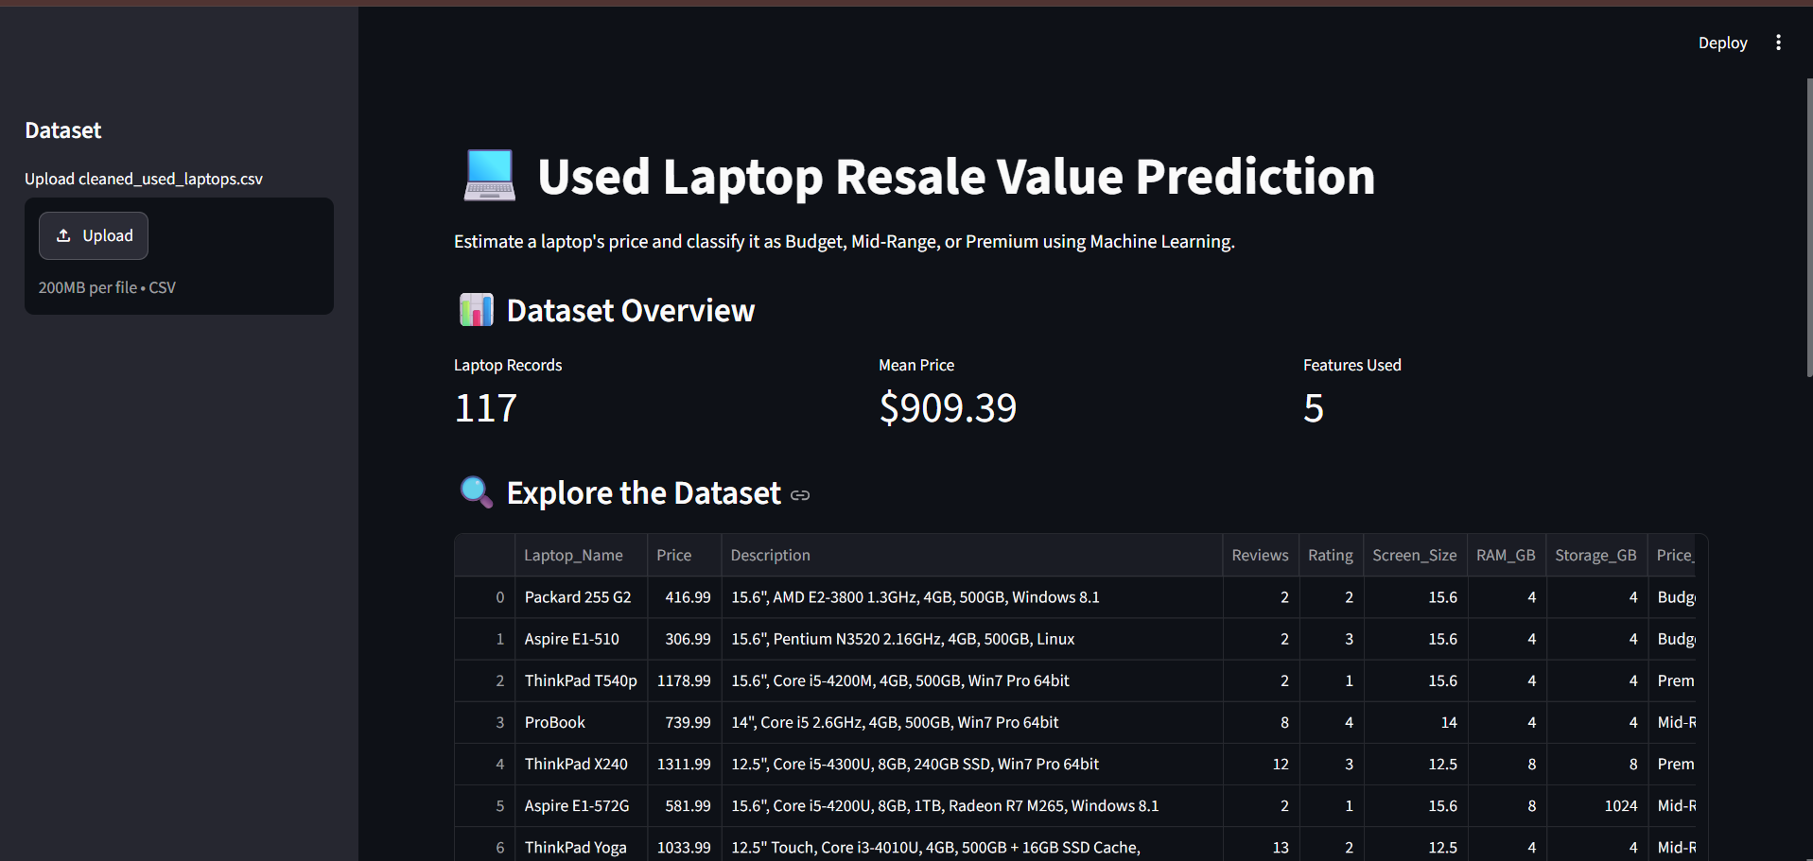
The overview reports 117 laptop records, a mean price of $909.39, and five model features. The table preview displays the listing data and engineered columns.
Figure 2. Prediction form and displayed estimated price/category.
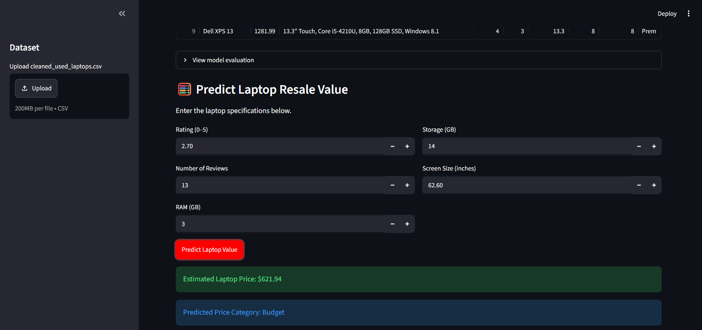
The form accepts five input values and displays an estimated laptop price of $621.94 and category Budget for the values shown in the screenshot.
Figure 3. Model evaluation metrics.
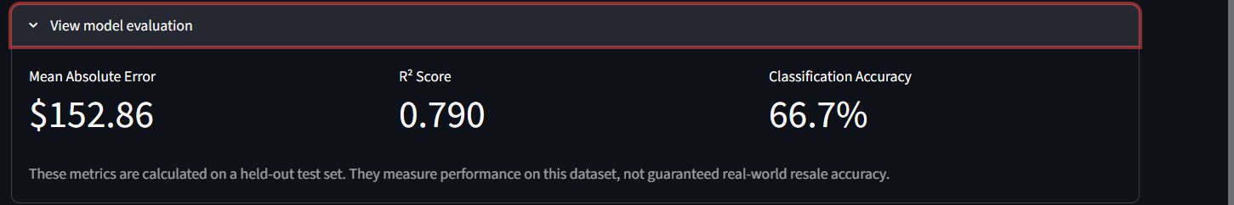
The evaluation panel reports MAE of $152.86, R² of 0.790, and classification accuracy of 66.7%. The interface itself notes that these results are measured on a held-out test set and do not guarantee real-world resale accuracy.

6.2 Result Analysis
- The Random Forest regressor outperformed the linear models and the single decision tree on the notebook's test split.
- The regression R² of approximately 0.79 suggests that the model explains a substantial portion of test-set price variation, but the MAE of about $153 means individual estimates can still be materially wrong.
- The Random Forest classifier reached about 66.7% accuracy on 24 test records. This is a modest result and should not be treated as high-confidence market classification.
- The dataset is small and derived from a static e-commerce test site; listed prices may not represent used-device resale transactions.
- Feature extraction errors—especially screen-size values extracted from model names—are a major limitation and should be fixed before deployment or real seller use.
- The interface trains models dynamically on the data it loads, while notebook metrics are based on a held-out split. The exact reported metrics may therefore differ slightly.

7. CONCLUSION
The project demonstrates an end-to-end machine-learning workflow for laptop price estimation and price-category classification. After collecting and preparing 117 records, five regression algorithms and three classification algorithms were compared. Random Forest Regression produced the strongest regression metrics (MAE $153.09; R² 0.7896), while Random Forest Classification achieved the highest classification accuracy (66.67%). A Streamlit interface allows users to enter laptop features and view predictions.
The current version is suitable as an academic demonstration, not as a dependable resale appraisal tool. Future improvements should correct specification extraction, use a larger dataset of actual used-laptop transactions, add age/condition/battery-health/processor/GPU features, validate with cross-validation and external test data, and retrain/version models reproducibly.

8. GITHUB LINK
GitHub Repository URL: https://github.com/sanikabhanuse677-cyber/SI-project_LAPTOPRESALE

9. REFERENCES
- Web Scraper e-commerce static laptop test site: https://webscraper.io/test-sites/e-commerce/static/computers/laptops
- Pandas documentation: https://pandas.pydata.org/docs/
- Scikit-learn documentation: https://scikit-learn.org/stable/
- Streamlit documentation: https://docs.streamlit.io/
- Matplotlib documentation: https://matplotlib.org/stable/
- Beautiful Soup documentation: https://www.crummy.com/software/BeautifulSoup/bs4/doc/
Note: Library versions, enrollment number, and GitHub URL were not present in the supplied materials and should be completed if required by the instructor.

